Daniel McDonough

3/25/17

HCI Project 2

Hypothesis:

If the line-length shrinks, it is expected for the reading speed (words per minute) to go down due to words being split and people having to take time to put words together. It is also expected that this is a continuous relation, for as the line length increases, the eye has less movements to make therefore increasing reading speed.

Expected Results:

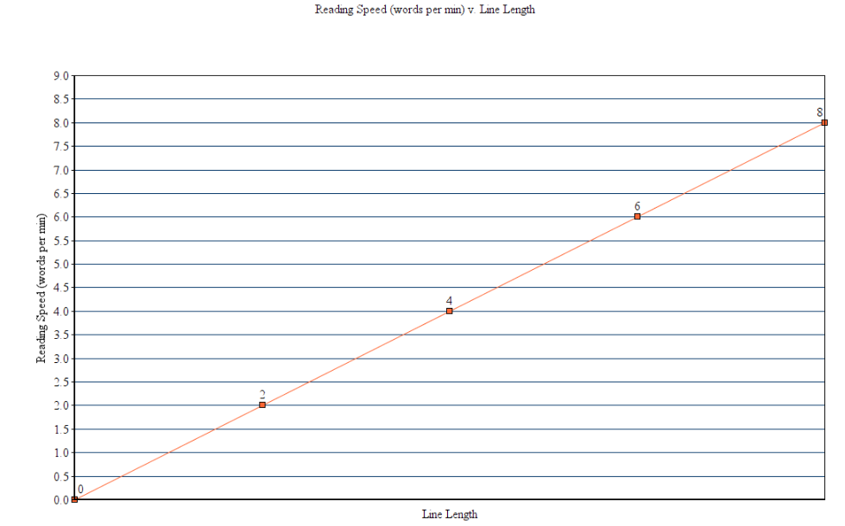

Overview:

In this experiment, we will test undergraduate students of Worcester Polytechnic Institute (WPI) due to convenience. All participant’s data are to be independent from the other. It is expected that WPI undergraduates whom are tested, are fluent in English and are able to read on a college level. Prior to the experiment, it is important to ask the participant how often they read books, birth sex, major(s), and graduating year in order to determine any possible extenuating factors or outliers. The experiment will have two line lengths (200px, 1000px) of two different passages, a 590-word section on page 8 of “The Pleasure of Finding Things Out” by Richard P. Feynman and the first 586 words or Carl Sagan’s “Cosmos”. Using a stopwatch, we can test approximately how many words a person reads per minute. The varied line lengths will be made in an HTML document with in-line CSS changing the line length like so; <p style="width: 1000px ;"> and <p style="width: 200px ;">. We will test a total of 12 people and then ask them a few questions about the passage to test their understanding and preference. The questions will ask about little facts at the start and end of the passage as well as the overall meaning of the passages. Six people will be tested for Feynman as the short line length and six will be tested for Sagan as the short line length to see if type of passage mattered. Even numbered participants will test the Feynman-short and Sagan-long case, where-as odd numbered participants will test the Feynman-long and Sagan-Short case. To avoid any other variables, they are expected to read the same passage on the same computer with the same brightness. Once all data is collected, we will use DESMOS to calculate the statistical analysis.

Procedure:

In this experiment voluntary participants are gathered and are asked to fill the first portion of the questionnaire. The questionnaire is folded so that you cannot see what the post reading questions are. The participants are informed that they will have to answer comprehension questions after the reading is complete. The participants will begin reading when the experimenter has a stop watch ready and says “begin” and the time will stop when the reader/participant says “done”. The participant will then answer the comprehension questions with no time limit and once finished they will be asked whether they preferred reading passage in a column style or the thicker style. Their choice will be circled on their sheet and will conclude the experiment.

General Data:

Figure 1:

|  |  |  |  |  |  |  |  |  |  |  |  |  |
| --- | --- | --- | --- | --- | --- | --- | --- | --- | --- | --- | --- | --- |
| Participant # | 1 | 2 | 3 | 4 | 5 | 6 | 7 | 8 | 9 | 10 | 11 | 12 |
| Birth Sex | F | F | M | M | M | F | M | M | M | M | F | F |
| Year | 2017 | 2018 | 2019 | 2019 | 2020 | 2020 | 2019 | 2020 | 2020 | 2019 | 2017 | 2017 |
| Major | BME | RBE | ME&ECE | Physics | ME&RBE | BB | ECE&CS | CE | CS | CS | BME | Physics |
| Depth/Skim | Skim | Depth | Skim | Depth | Skim | Skim | Skim | Skim | Depth | Skim | Depth | Skim |
| Read Freq. (hr/day) | 2.5 | 15 | 0 | 2 | .6 | 3.5 | 0 | 1 | 4 | 2 | 1 | 5 |
| 1000px Reading time | 32 sec | 113 sec | 133 sec | 216 sec | 118 sec | 140 sec | 91 sec | 160 sec | 112 sec | 316 sec | 255 sec | 95 sec |
| 1000px Words Per minute * | 1106 wpm | 311 wpm | 313 wpm | 163 wpm | 300 wpm | 251 wpm | 389 wpm | 220 wpm | 316 wpm | 111 wpm | 138 wpm | 370 wpm |
| 200px Reading time | 60 sec | 114 sec | 267 sec | 202 sec | 114 sec | 150 sec | 120 sec | 132 sec | 106 sec | 223 sec | 325 sec | 100 sec |
| 200px Words per minute * | 586 wpm | 310 wpm | 131 wpm | 175 wpm | 308 wpm | 236 wpm | 293 wpm | 268 wpm | 331 wpm | 159 wpm | 108 wpm | 354 wpm |
| Comprehension 1000px | 3/3 | 3/3 | 1/3 | 2/3 | 0/3 | 1/3 | 2/3 | 2/3 | 3/3 | 0/3 | 1/3 | 1/3 |
| Comprehension 200px | 3/3 | 3/3 | 0/3 | 1/3 | 0/3 | 3/3 | 0/3 | 1/3 | 0/3 | 0/3 | 0/3 | 3/3 |
| Preference | Long | Short | Long | Long | Short | Short | Short | Long | Long | Short | Long | Long |

*Odd numbered participants read a 1000px 590 word article, and Even numbered participants, read a 1000px 586 word article. Even numbered participants read a 200px 590 word article, and Odd numbered participants, read a 200px 586 word article.

Figure 2:

|  |  |  |
| --- | --- | --- |
| Length Size: | 1000px | 200px |
| Average WPM: | 332.3 | 272.8 |
| Min WPM: | 111 | 108 |
| Max WPM: | 1106 | 586 |
| Q1 WPM: | 191.5 | 167 |
| Q2 WPM: | 305.5 | 280.5 |
| Q3 WPM: | 343 | 320.5 |
| IQR WPM: | 151.5 | 153.5 |
| Outliers: | 1106 | 586 |
| Average WPM No Outliers: | 262 | 243 |
| Average Comprehension | 50% | 38% |

Figure 3:

|  |  |  |  |  |  |  |  |  |  |  |
| --- | --- | --- | --- | --- | --- | --- | --- | --- | --- | --- |
| Line-length | Evens* | Odds** | Odds-  no Outliers*** | Even* Com-prehension |  | Odd**  com-prehension | Feynman*** | Sagan | Feynman  Compr-ehension | Sagan  Compr-ehension |
| 1000px | 237.6 | 427 | 291.2 | 46/100 |  | 53/100 | 291.2 | 237.6 | 53/100 | 46/100 |
| 200px | 250 | 292.8 | 234.2 | 60/100 |  | 17/100 | 250 | 234.2 | 60/100 | 17/100 |

*Even numbered participants read 1000px Sagan and 200px Feynman

**Odd numbered participants read 1000px Feynman and 200px Sagan

***Participant #1 was an outlier, this data represents the Avg. wpm without them.

Figure 4: Feynman v Sagan 1000px

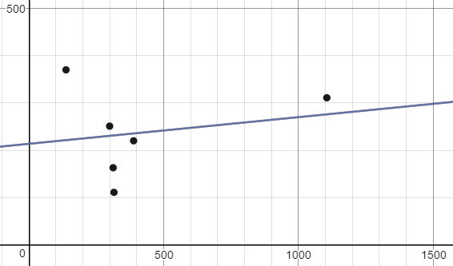

Y = 0.056343(WPM Feynamn)+213.61

R = 0.204

Figure 5: Feynman v Sagan 200px

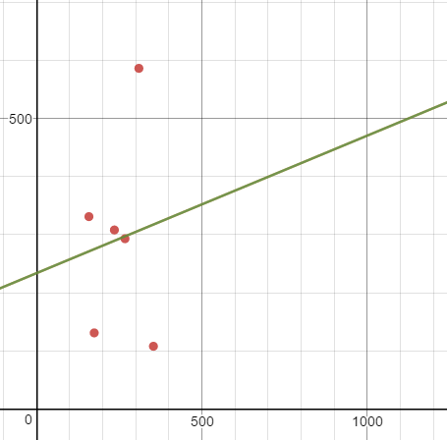

Y = 0.23655(WPM Feynamn) +233.62

R = 0.104

Figure 6: WPM v. Line-Length (with Outliers)

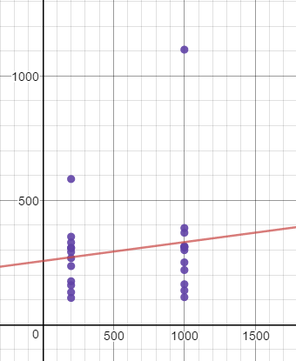

R = 0.153

Y = 0.075938(Line Length) + 256.4

Figure 7: WPM v. Line-Length (without Outliers)

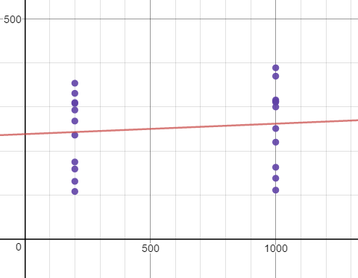

Y = 0.02375(Line Length) + 238.25

R = 0.11

Figure 8: Line Length v Comprehension

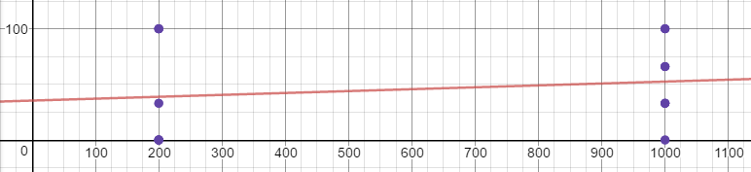

Y = 0.017083(Line Length) + 35.417

R = 0.168

Analysis of two passages:

Before testing the correlation between line-length and reading speed, we must test if the two articles resulted in similar speeds and comprehension. At first glance it seems that those who read the Feynman passage at 1000px had an easier time resulting in higher words per minute than those who read the Sagan passage at 1000px (Figure 3). When looking at the data closely however, you can see that the first participant was clearly an outlier and caused the odd numbered participant data to be skewed. After removing them from the average, the odd participant’s average wpm becomes closer to the even participant’s average wpm. The data shows however, that this difference is still too small, as the Feynman passage readers still tend to have a higher reading rate and comprehension than when reading the Sagan passage. If the reading times were the same, then the correlation coefficients would have been less than 0.05 however, both are greater than 0.05 meaning that just by reading the Feynman passage one is statistically likely to have a greater reading speed and comprehension than those who read the Sagan passage (Figures 5 & 6). This may have happened due to the styles of writing in which the two passages were written in. Sagan may have been too difficult of a style to understand which may have caused the participants to reread the passage to attempt to get a good understanding of the complex concepts of the passage. Even though, the two passages may have resulted in significantly different data, the variation of the difficulty of passages will increase the validity of the experiment.

Analysis of Reading Speed v. Line Length:

Again at first glance, one could say that there is a positive correlation between line-length and reading speed (Figures 6 & 7). This conclusion can especially be drawn upon from including the outliers which skew the data. With or without the outliers however, there is still not enough statistical evidence to say that there is a correlation between line lengths and reading speed, for the correlation coefficient is always greater than 0.05. There seems to be a weak correlation as it stands with the coefficient being about .1, and by looking at the current trend, it is possible to estimate that with further experimentation it is possible to conclude that there may be a correlation. Due to errors with the passages that were previously stated, when looking at the comprehension of the passages to the line-length they were presented in there tended to be errors in the data collected. These errors may have skewed the correlation data, which is much greater than 0.05, showing that there is little correlation (if at all any) that can only be proven with further experimentation.

Conclusion:

Upon review of preferences, a simple majority preferred reading in the 1000px format. This seems to correspond to the positive correlation of reading speeds to longer line lengths. This provides insight to relate that consumers actually know what they want. This may have been skewed by the passages themselves or the luck of indifference and the participant being forced to choose one. This experiment can be expanded upon by checking edge chases such as a line length of one letter or having the entire passage on one line. These cases may provide insight to how reading preferences are formed and to locate a sweet spot for line-length as the results may not be a linear regression but rather a bell curve. Furthermore, this experiment contains errors such as difference in passage composition, choice in questions, lack of line length range, and low sample size. These errors resulted in inconclusive data, or there is no true correlation between line length and reading speed.

References & Materials:

Feynman, Richard P., Jeffrey Robbins, and Freeman J. Dyson. The Pleasure of Finding Things Out: The Best Short Works of Richard P. Feynman. London: Penguin, 2007. Print.

Poundstone, William. Carl Sagan: A Life in the Cosmos. New York: Henry Holt, 2000. Print.

Desmos Graphing Calculator. N.p., n.d. Web. 02 Apr. 2017.